Perceptual object continuity is not governed by core-cognitive principles

Commentary on Bai et al.

E. J. Green (Johns Hopkins University) & Jake Quilty-Dunn (Rutgers University—New Brunswick)

William H. Miller III Department of Philosophy
Johns Hopkins University
281 Gilman Hall
3400 N. Charles Street
Baltimore, MD 21218

Rutgers Philosophy Department
College Avenue Campus
106 Somerset St
5th Floor
New Brunswick, NJ 08901

egreen77@jh.edu
jake.quilty-dunn@rutgers.edu

https://sites.google.com/site/greenedwinj/
https://sites.google.com/site/jakequiltydunn/

Word counts: Abstract: 59; Main text: 940; References: 370; Entire text: 1543.

Abstract:

Bai et al. claim that perceptual and core-cognitive object tracking operate according to common principles, including cohesion and spatiotemporal continuity. This claim is false: perceptual object continuity is not strictly governed by cohesion or spatiotemporal continuity. We must therefore either reject Bai et al.’s relocation of core-cognitive processes within perception or adopt more radically revisionary attitudes toward core cognition.

Main text:

Bai et al. offer a sweeping, evidentially rich case that many capacities traditionally attributed to core cognition actually reflect the operations of our perceptual systems. While we agree that there are salient parallels between the two domains, we disagree with a central plank of their argument: the claim that perception of object continuity is strictly governed by the same principles of cohesion and spatiotemporal continuity that are typically thought to govern core-cognitive representation of object continuity. These principles are neither necessary nor sufficient for perceptual object continuity (Figure 1). We contend that Bai et al. face a dilemma: either concede that object perception is distinct from core object cognition, or embrace a revisionary conception of core object cognition.

Spelke’s cohesion principle states that “two surface points lie on the same object only if the points are linked by a path of connected surface points” (1990, 49). Intuitively, cohesion requires that objects are topologically continuous, not fragmented. The table is cohesive, while the sum of the table and the chair is not. Bai et al. claim that “cohesion violations frustrate object representation both in infants and in adults, and…these violations have consequences for visual processing”. Against this, however, maintenance of cohesion is neither necessary nor sufficient for the perception of object continuity, and apparent evidence for a cohesion constraint on object tracking may instead be explained by perceptual sensitivity to coherent motion signals throughout an object (Green 2018).

First, studies have found that multiple-object tracking (MOT) performance is generally unaffected by cohesion violations as long as the non-cohesive fragments move as a tight cluster. Alzahabi and Cain (2021) found that subjects could track up to four groups containing 2, 4, or 8 disconnected dots with minimal loss of accuracy, and at levels comparable to the tracking of cohesive objects. While the targets in this study were non-cohesive from the outset, other findings suggest that even the visible loss of cohesion does not always impair tracking. Bai et al. cite one of vanMarle and Scholl’s (2003) experiments in favor of the similarity between perceptual and core-cognitive object tracking, but another experiment within the same study revealed that when initially cohesive squares disintegrated into non-cohesive fragments that moved as a perceptual group, tracking performance was unimpaired.

Second, other studies show that maintenance of cohesion is not sufficient for tracking success, even when spatiotemporal continuity is also maintained. For example, tracking performance is equally impaired for both nonrigidly expanding and contracting objects (which maintain cohesion) and “pouring” noncohesive substances (vanMarle & Scholl 2003; Howe et al. 2013). More generally, performance in MOT may depend chiefly on coherent motion signals across the parts of a target, rather than on cohesion per se (St. Clair et al. 2010; Alzahabi & Cain 2021): when uniform motion is present but cohesion is not, tracking succeeds; when cohesion is present but uniform motion is not, tracking fails.

One might respond to this evidence by relaxing the appeal to Spelke’s properties and instead emphasizing a common reliance on spatiotemporal properties more generally, such as spatial continuity. However, even this more modest view does not withstand scrutiny. Continuity of trajectory is neither necessary nor sufficient for visual object tracking.

First, spatial continuity is not necessary. When cues to spatiotemporal continuity are either absent or ambiguous, the visual system can use color and other surface features to reidentify objects. When a red and blue object disappear behind the same occluder, visual object representations use color to establish object continuity (Hollingworth & Franconeri 2009). When participants execute a saccade toward an object and the objects move during the saccade such that the gaze lands exactly between them, automatically initiated corrective saccades rely on surface features to reidentify the target object (Hollingworth et al. 2008; Richard et al. 2008).

Second, spatial continuity is not sufficient; even in cases where spatial trajectory is clear and unambiguous, it does not dominate surface features in determining tracking. Bai et al. cite the famous tunnel effect, wherein object tracking is unaffected by changes in surface features that occur behind occluders. However, when those changes occur in clear view (i.e., not under occlusion or long-range apparent motion) and more sensitive measures of object tracking are used, perception of object continuity is indeed disrupted (Moore et al. 2010; Jiang 2020). Furthermore, in apparent motion paradigms, spatiotemporal properties like interstimulus interval yield reliable psychophysical curves – e.g., shorter intervals bias perception toward individual-object motion rather than entire-group motion in Ternus displays (Pantle & Picciano 1976). But surface features easily override this bias in displays where those features are informative about object continuity (Hein & Moore 2012; Hein & Moore 2014). In other words, surface features are consulted by perceptual object tracking processes alongside spatial continuity and will dominate spatial continuity in many ordinary contexts (see also Moore & Enns 2004; Moore et al. 2007).

How to theorize about the dynamics of feature use in perceptual object tracking is a topic we have pursued elsewhere, arguing for a flexible, syntactically structured tracking system governed by context-dependent shifts in the informativeness and reliability of feature dimensions (Quilty-Dunn & Green 2023). With respect to Bai et al.’s proposal, we see two plausible options: either we should reject Bai et al.’s central thesis and distinguish perceptual object continuity from core-cognitive object continuity; or we should adopt a more revisionary approach toward core cognition than Bai et al. suggest, and reject the centrality of the Spelke criteria and dominance of spatiotemporal properties for object continuity in core cognition as well as perception. Whichever approach one adopts, Bai et al.’s attempt to preserve traditional principles of core-cognitive object continuity while relocating them within perception is not empirically sustainable.

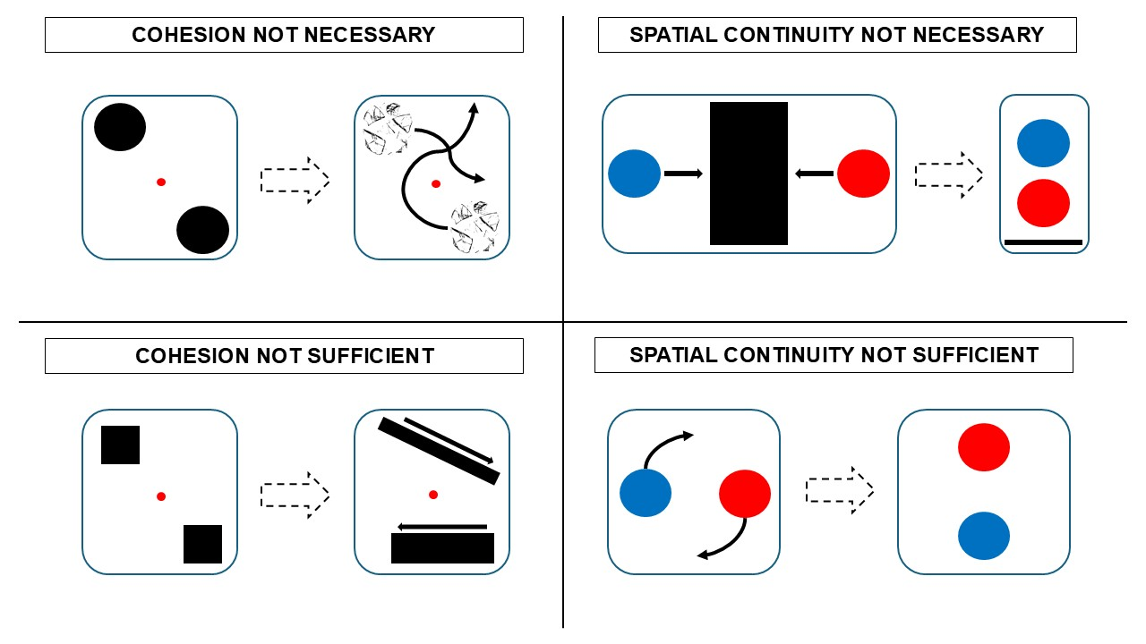
Figure 1–Clockwise from top left: multiple-object tracking succeeds despite cohesion violations; object-specific preview benefit succeeds based on surface features when spatial location is undetermined; object-specific preview benefit is disrupted when objects abruptly change surface features in clear view; multiple-object tracking is disrupted by lack of coherent motion signals in expanding/contracting objects despite cohesion. Solid arrows represent motion paths, dotted arrows represent change in phase of stimulus displays (e.g., motion phase to test phase, target selection phase to multiple-object tracking phase).

Acknowledgments:
None.

Competing interests statement:
None.

Funding statement:
None.

References

Alzahabi, R., & Cain, M. S. (2021). Ensemble perception during multiple-object tracking. Attention, Perception, & Psychophysics, 83(3), 1263-1274.
Green, E. J. (2018). What do object files pick out?. Philosophy of Science, 85(2), 177-200.
Hein, E., & Moore, C. M. (2012). Spatio-temporal priority revisited: the role of feature identity and similarity for object correspondence in apparent motion. Journal of Experimental Psychology: Human Perception and Performance, 38(4), 975.
Hein, E., & Moore, C. M. (2014). Evidence for scene-based motion correspondence. Attention, Perception, & Psychophysics, 76(3), 793-804.
Hollingworth, A., & Franconeri, S. L. (2009). Object correspondence across brief occlusion is established on the basis of both spatiotemporal and surface feature cues. Cognition, 113(2), 150-166.
Hollingworth, A., Richard, A. M., & Luck, S. J. (2008). Understanding the function of visual short-term memory: transsaccadic memory, object correspondence, and gaze correction. Journal of Experimental Psychology: General, 137(1), 163.
Howe, P. D., Holcombe, A. O., Lapierre, M. D., & Cropper, S. J. (2013). Visually tracking and localizing expanding and contracting objects. Perception, 42(12), 1281-1300.
Jiang, H. (2020). Effects of transient and nontransient changes of surface feature on object correspondence. Perception, 49(4), 452-467.
Moore, C. M., & Enns, J. T. (2004). Object updating and the flash-lag effect. Psychological Science, 15(12), 866-871.
Moore, C. M., Mordkoff, J. T., & Enns, J. T. (2007). Path of least persistence: Object status mediates visual updating. Vision Research, 47, 1624–1630.
Moore, C. M., Stephens, T., & Hein, E. (2010). Features, as well as space and time, guide object persistence. Psychonomic Bulletin & Review, 17(5), 731-736.
Pantle, A., & Picciano, L. (1976). A multistable movement display: Evidence for two separate motion systems in human vision. Science, 193(4252), 500-502.
Quilty‐Dunn, J., & Green, E. J. (2023). Perceptual attribution and perceptual reference. Philosophy and Phenomenological Research, 106(2), 273-298.
Richard, A. M., Luck, S. J., & Hollingworth, A. (2008). Establishing object correspondence across eye movements: Flexible use of spatiotemporal and surface feature information. Cognition, 109(1), 66–88.
Spelke, E. S. (1990). Principles of object perception. Cognitive Science, 14(1), 29-56.
St. Clair, R., Huff, M., & Seiffert, A.E. (2010). Conflicting motion information impairs multiple
object tracking. Journal of Vision, 10(4): 18, 1-13.
VanMarle, K., & Scholl, B. J. (2003). Attentive tracking of objects versus substances.
Psychological Science, 14(5), 498-504.

